Business Blueprint

Sales and Distribution



Project Intelligent Logistic Routing & Shipment Planning ( DO and Reference Interface)

OBJECTIVE

Business Blueprint document is a documentation of functional requirements and non-functional requirements of application modules to support the needs of the business areas that are included in the scope of the SAP system implementation. This document also describes the overall processes are supported by application module and detailed requirements that include functional, data, forms, reports (report), and interfaces. These needs will be based on the agreed scope of the project in the Project Charter
This document will become a base for activities of the technical design, customization and testing the SAP application modules in the PT. SMART DOWNSTREAM, which refers to the Project Charter.

Document Changes Control

Version | Date | By | Summary of changes
1.0 | 05-09-2017 | Felicia M Cynthia | Initial document

Validation Sheet

Sales Distribution
(DO and Interface)
SD Functional | SD Functional | Project Manager
Felicia M Cynthia | Ronald S. Susanto | Kent Suryadinata
PT. SMART Tbk | PT. SMART Tbk | PT. Smart, Tbk
Technology Intelligent Routing | Technology Intelligent Routing | Technology Intelligent Routing
Subhan Nur Ichwan | Ajie Bharoto | Eri Fizal
PT. Sinarmas Distribusi Nusantara | PT. Sinarmas Distribusi Nusantara | PT. Sinarmas Distribusi Nusantara
Project Management Officer | Key User (LOG) | Business Process Owner (LOG)
Y. Kandi Priharsi | Agus Law | Fenny Chandra
PT. Sinarmas Distribusi Nusantara | PT. Sinarmas Distribusi Nusantara | PT. Sinarmas Distribusi Nusantara
SAP Team

No | Name | Company
1 | Ronald S. Susanto | SMART Tbk
2 | Felicia M Cynthia | SMART Tbk
3 | Yoko | SMART Tbk
4 | Haider | SMART Tbk

TABLE OF CONTENTS
Business Process do and interface 6
1. OVERVIEW 6
1.1. Background 6
1.2. business requirement 9
1.3. Process Flow Diagram 11
2. SAP SYSTEM ENHANCEMENT 13
2.1. overview 13
2.2. sap enhancement 13
2.2.1. Create program send transaction data to intelligent route 13
2.2.2. Create program send Delivaery Order have shipment planned 14
2.2.3. Added program send customer and vehicle master data for current program 14
2.3. environments 14
2.3.1. Intelligent Route to SAP Integration 14
2.3.2. SAP To Intelligent Route 15

Business Process do and interface

- OVERVIEW
  - Background
This SAP enhancement is interfacing of DO and reference data to enable seamless data transfer to “Intelligent Routing”.
Delivery Order can be copied directly database to database upon document creation and update, with ways to indicate which one not Shipment Planned yet.
How to send transaction data delivery which is not planned to be shipment yet. The data transaction it self are: Delivery Order Header, Delivery Order Item, and for Master Data is Customer Data, Vehicle Data.
As planned the data transaction will be send to Database SDN (for used Intelligent Routing) every twice a day at 11am and 3pm from SAP.
For Data Customer and Vehicle will be send to Database SDN (for used Intelligent Routing) before send data transaction, that is every twice a day at 10am and 2pm from SAP.
Field Data Customer which will be sent is :
Field | Status  (New/Exist) | Notes
CustID | Exist
Longitude | Exist
Latitude | Exist
Priority | New | Need Added at current program sending data Customer
Distribution channel | Exist
CustCategory | Exist
BranchCode | Exist
Kelurahan | Exist
Kecamatan | Exist
Address | Exist
ZipCode | Exist
Nama Toko | Exist
Note : Exist → send by current interface
New → Need field
Field Data Vehicle which will be sent :
Field | Status  (New/Exist) | Notes
VehicleId | Exist
Vehicle Type | New | Need added data material for vehicle type and Need Added at current program sending data vehicle
TotalKG | New | Need Added at current program sending data vehicle
TotalCubication | New | Need Added at current program sending data vehicle
BranchCode | Exist
RecordCreationDateTime | New | Need Added at current program sending data vehicle
Note : Exist → send by current interface
New → Need field
Field data delivery header will be send is :
Field | Status  (New/Exist) | Notes
DONum | New
CustomerID | New
TotalKG | New
TotalAmt | New | Sum total Net amount from delivery item
RequestDeliveryDate | New
Route | New
Note : Exist → send by current interface
New → Need field

Field Data Delivery Item will be send :
Field | Status  (New/Exist) | Notes
DONum | New
DOLineItem | New
ProductID | New
ProductDesc | New
TotalKG | New
TotalCubication | New
GrossAmount | New | NetAmount + PPN
NetAmount | New | (Value Sales Order / Qty Sales Order ) * Qty Delivery Order
RecordCreationDateTime | New
Qty Deliv | New
Batch | New
High.lvl.Batch | New
Deliv.Item Category | New
Shift | New | Shift1 (11am) and Shift2 (3pm)
Status Shipment | New | Delivery Order have shipment planned
Flag | New | Status success from Intermediate DB
Note : Exist → send by current interface
New → Need field
  - business requirement
SAP can transfer/send data Delivery Order, Delivery Order Item, to “Intelligent Routing” every twice a day at 11am and 3pm from SAP, with a condition that Delivery Order do not have shipment planned. For Data customer and vehicle send every twice a day at 10am and 2pm from SAP before data transaction sent.
The Data Delivery that would be sent is based on both the data creation date and creation time. SAP will create a custom program for this proposed solution
SAP will send with ABAP proxy by PI.
There are 2 ways/batch/steps for User when they send the data transaction, there are:
    - Data created and changed between 3pm – 11am
    - Data created and changed between 11am – 3pm
There are 2 ways/batch/steps for User when they send the data master, there are:
    - Data created and changed between 2pm – 10am
    - Data created and changed between 10am – 2pm
User should be created shipment planned manually in SAP based on intelligent route, during shipment planned has not been sent from intelligent route to SAP automatically. If user has not created shipment planned when send data from SAP to intelligent route, then delivery data will be sent back.
If there is any additional or data need to be change inside DO, user must be a change DO as usual, after that, the data have to follow the next batch or it can run manually using the program. User can selection program by DO Number, branch (sales office), date, time, distribution channel.
SAP will send the successful DO data that has Shipment Planned as long as the
Shipment Planned has not been sent from Intelligent Route automatically
SAP will send the successful DO data that has Shipment Planned as long as the Shipment Planned has not been sent from Intelligent Route automatically.

  - pROCESS FLOW Diagram
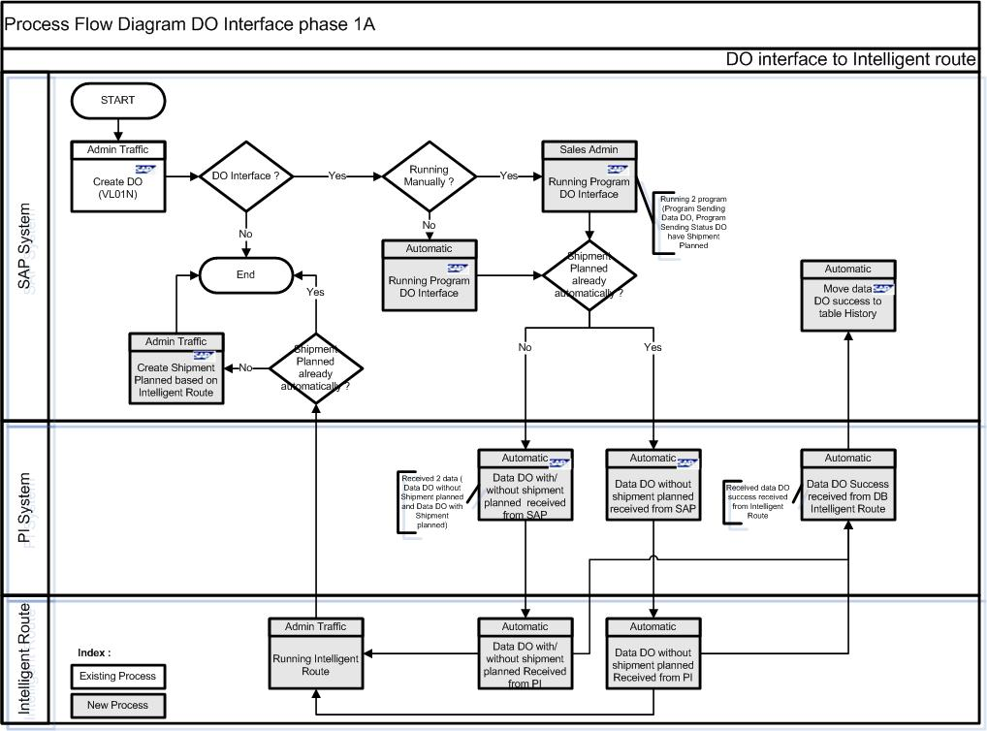
SAP
Create Delivery Order
Create Sales Order
Program Send Delivery Order Data
PI
Program Send Delivery Order Data
Intelligent Route
Delivery Order Data
a
b
d
e
f
c
- Create Sales Order
Create Sales Order as usual.
- Create Delivery Order
Create Delivery Order based on Sales Order as usual.
- Send Delivery Order
There is program custom for send data (Sales and Delivery Data, Delivery Item data and vehicle Data ) every twice a day based on date creation and change via PI. Delivery will be sent with condition delivery don’t have shipment planned .
Program custom for transaction have two variant, there are:
- Variant for send data between 3pm until 11am
- Variant for send data between 11am until 3pm
SAP can send two data, there is;
- Data Delivery
- Total of data delivery that SAP send

- PI Send to Intelligent route
Delivery Order Data will be sent to Intelligent Route via PI and using ABAP Proxy on Database to Database.
Intelligent Route get data DO header and Item based on checked Shift 1 and Shift 2 and get field Already_shipment with status ‘n’.
- Intelligent Route send to PI
Intelligent Route can send data Delivery Order success to SAP via PI.
Sending flag ‘1’ if success intelligent route get Data DO.
- PI send status to SAP
Delivery data that success from intelligent route will be send to SAP for information data from SAP success received by intelligent route.
- SAP System enhancement
  - overview
The involved Systems for the Integration Scenarios are SAP ERP, SAP PI and Intelligent Route System. The communication between SAP ERP and SAP PI will be executed via Proxy Interfaces. And between SAP PI and Intelligent Route System via Database to Database. The Data Exchange between Intelligent Route System and SAP ERP for Transactions must be executed twice a day.
  - sap enhancement
    - Create program send transaction data to intelligent route
Delivery data, Delivery item Data, Vehicle data will be send on twice a day ~ 11am & 3pm from SAP. Selection at Program Custom consists of DO Number, Date, Time and sales office (Branch). SAP can send two data, there is Total data transaction to be sent and the transaction data according to data selection.
If there is any error as data not sent or system shut down, Program can be running back date and can be resent.
Enhancement #1:
Need to develop a new program for send data Delivery
Need to develop PI for connecting SAP and Intelligent Routing
Need to create Variant at new program for background job
    - Create program send Delivaery Order have shipment planned
SAP will be send data DO success a have shipment planned during shipment planned has not been sent from intelligent route to SAP automatically. SAP will send flag DO have shipment to intelligent route.
Enhancement #2:
Need to develop a new program for send data Delivery have shipment planned
Need to develop PI for connecting SAP and Intelligent Routing
Need to create Variant at new program for background job
    - Added program send customer and vehicle master data for current program
Customer and Vehicle data will be send based on current process. At TMS project we need added some field. For master data will be sendi twice a day ~ 10am & 2 pm from SAP.
If there is any error as data not sent or system shut down, Program can be running back date and can be resent.
Enhancement #3:
Need to develop for changed program for added field into data vehicle master.
Need to develop for changed program for upload customer.

  - environments
      - Intelligent Route to SAP Integration
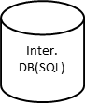
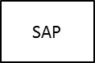
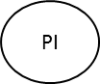

Intelligent Route
Intelligent Route (SQL)
1
2
3
4
5
Note :
1 : Intelligent Route to PI using Web service
2 : PI to SAP using Proxy
3 : SAP to PI using Proxy
4 : PI to Intermediate Database (SQL) using JDBC (Java Database Connector)
5 : Intermediate DB to Intelligent Route DB

    - SAP To Intelligent Route
Intelligent Route
  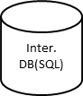  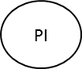 |  | 1 |  | 2
 |  |  |  |  |   3 | Intelligent Route
 | Note :
 | 1 : SAP to PI using Proxy/ Idoc
 | 2 : PI to Database (SQL) using JDBC (Java Database Connector)
 | 3 : Intermediate DB to Intelligent Route DB

